**Name:**  **Session:**

**Programming II**

**Lab Exercise 3.30.2022**

In this activity, you are to develop an application to test these two functions. You may either use a Windows Application.

1. You are tasked to develop a software package that requires users to enter their passwords. The password is required to meet the following criteria:

* The password must be at least 6 characters long
* The password must contain at least one numeric digit and at least one alphabetic character

Create an application that asks the user to enter a password. The application will use a function named *isValid* to verify the password meets the criteria. It should display a message indicating whether the password is *valid* or *invalid*.

The isValid function will accept a string as its argument and return a Boolean value. The string argument is the password to be checked. If the password is valid, the function returns *True*, otherwise it returns *False*.

Hint: Here are two functions that can assist you

Char.IsNumber(pw[i]) where pw[i] is the ith character in a string

Char.IsLetter(pw[i]) where pw[i] is the ith character in a string

Each of these functions return a Boolean value (True of False)

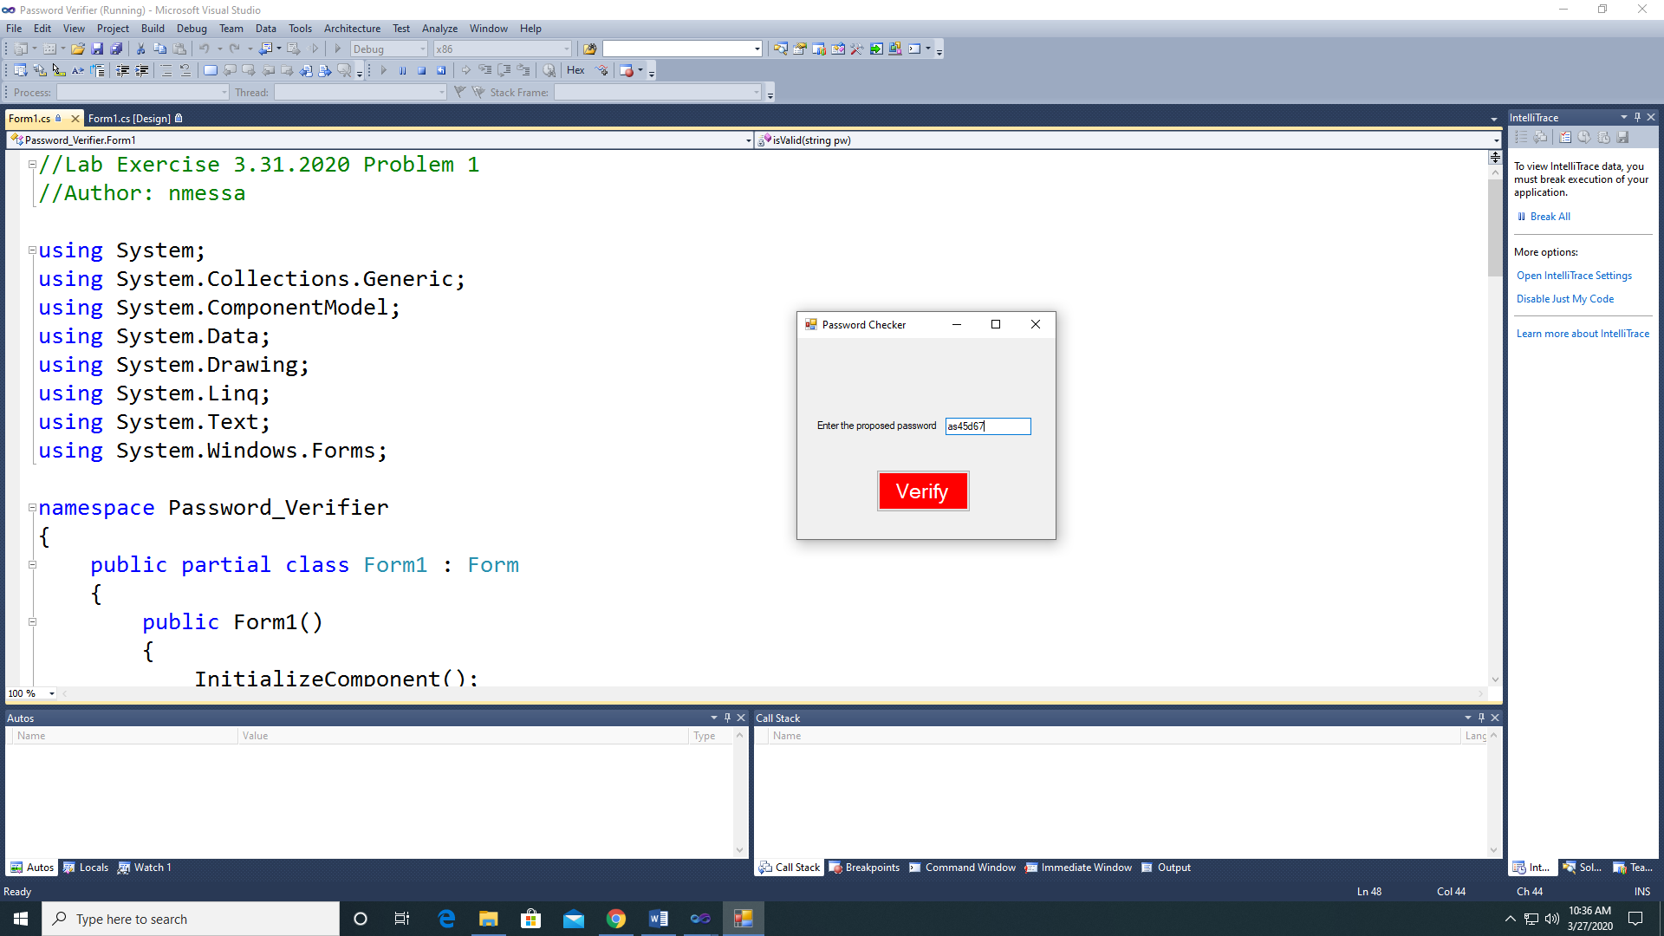 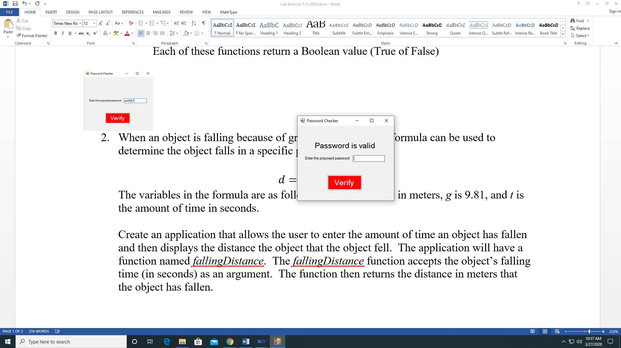

Before Verify Clicked After Verify Button Clicked

1. When an object is falling because of gravity, the following formula can be used to determine the object falls in a specific period:

$$d=1/2gt^{2}$$

The variables in the formula are as follows: *d* is the distance in meters, *g* is 9.81, and *t* is the amount of time in seconds.

Create an application that allows the user to enter the amount of time an object has fallen and then displays the distance the object that the object fell. The application will have a function named *fallingDistance*. The *fallingDistance* function accepts the object’s falling time (in seconds) as an argument. The function then returns the distance in meters that the object has fallen.

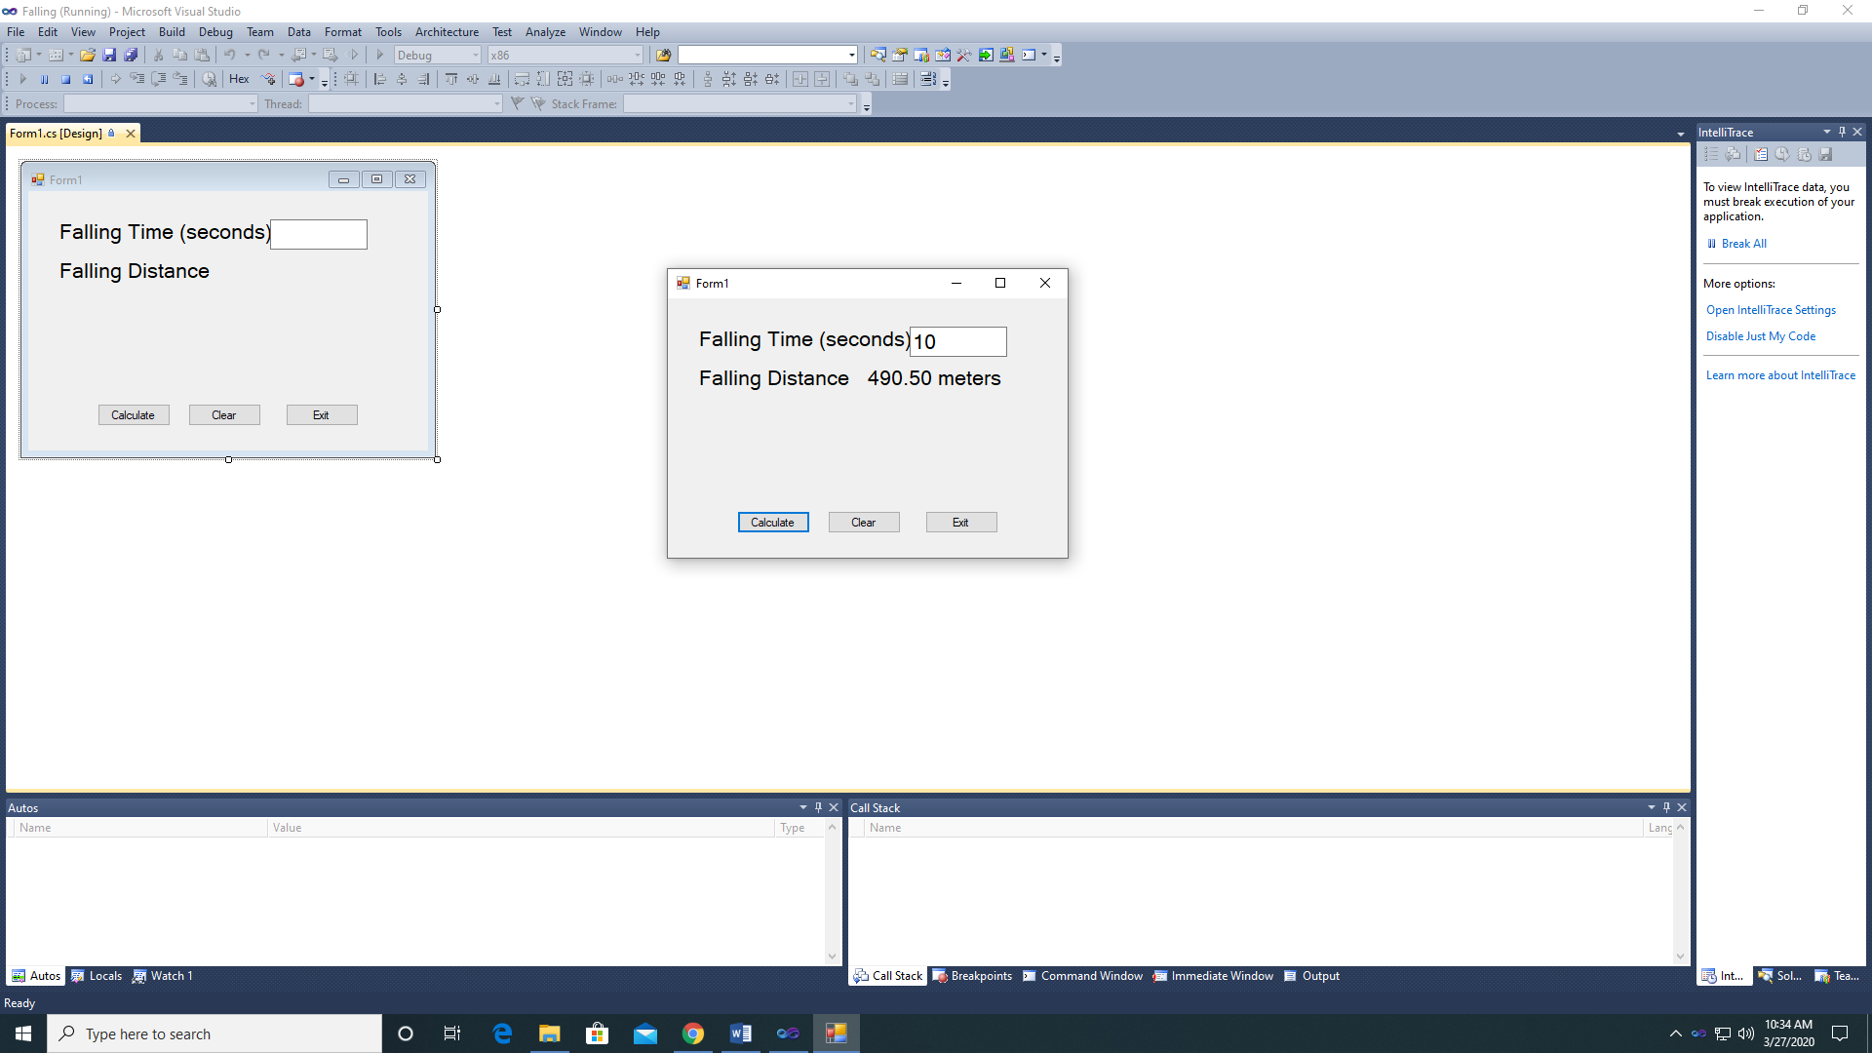

**When you have completed these 2 applications, submit a copy of your source code and a screenshot of your running program.**